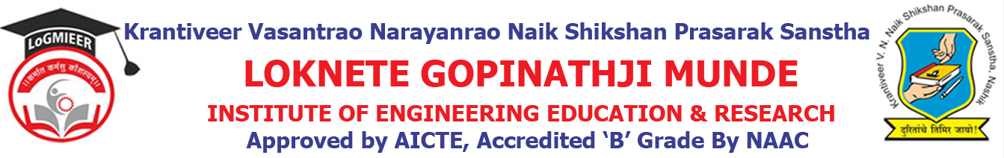
Department of AIML Engineering
ACADEMIC CALENDER-2022-23 SEM I
Sr. No. | Details of Activities | Weeks & Dates
1 | Practical Validation | Week 1 | 01/08/2022 to 10/08/2022
2 | Course File & Practical File Checking | Week 1 | 01/08/2022 to 10/08/2022
3 | Commencement of Teaching: TE & BE | Week 1 | 28/07/2022 to 01/08/2022  _.
4 | Commencement of Teaching: SE | Week 2 Onwards | 28/08/2022
5 | Unit Test I | Week 5 Onwards | 05/09/2022 to 09/09/2022
6 | Feedback Phase I | Week 10 | 19/08/2022 to 24/08/2022
7 | In-Sem Exam | Week 11 | 26/08/2022 to 30/08/2022
8 | Expert Talk | Week 03 to Week 13 | 01/09/2022 to 15/09/2022
9 | Value Added Courses/Workshop | Week 03 to Week 13 | 07/08/2022 to 16/10/2022
10 | Industrial Visits | Week 12 | 8/09/2022
11 | Parent Meet | Week 15 | 29/09/2022
12 | Conclusion of Teaching: TE | Week 16 | 31/09/2022 to 05/10/2022
13 | Feedback Phase II | Week 16 | 31/09/2022 to 05/10/2022
14 | Academic Letter to Parents | Week 16 | 31/09/2022 to 05/10/2022
16 | Final TW Sub-mission | Week 16 | 08/10/2022
17 | Remedial Classes | Week 16 | 31/10/2022 to 05/11/2022
18 | Conclusion of Academic: TE& BE | Week 21 | 04/11/2022
19 | Conclusion of Academic: SE | Week 18 to Week 21 | 04/12/2022
20 | Theory Exam | Week 19 Onwards | 5/12/2022

Prof.A.S.Nalge Prof. N. V. Kapade
Academic Co-ordinator HOD

